Give DFAs for following languages (1- 3) over the alphabet { 0,1}.
1. L= {w ∈ { 0, 1}∗ | w does not end with 10 }
2. All strings over Σ = {0, 1}, when interpreted as binary integer, is a multiple of 3, possibly with redundant leading 0.
3. The set of all strings such that each block of three consecutive symbols contains at least two 0’s.
4. Design an NFA with no more than six states for L = {w∈{0, 1}∗ | w contains an even number of 0s, or exactly two 1s }.
5. Design an NFA within four states for the language { 0 }* ∪ { 01 }*.
6. Design an NFA for the following language with five states: L = { w | w ∈ {0, 1}, w contains the substring 1011}.
7. Design an NFA for L = { w∈{0,1}∗ | w contains an equal number of occurrences of the substrings 01 and 10 }
8. Convert the following NFA into DFA with subset construction.
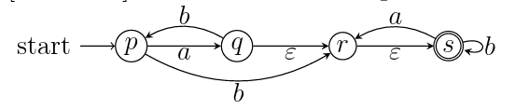
9. Convert the following DFA to a regular expression by eliminating states. Draw a diagram for every step that you eliminate a state.
